The console output:

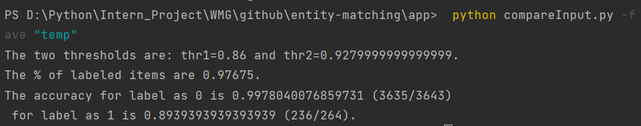

**Inconsistent results:**

1. For fuzzy matching label = 0:



1. #71 is about the album vs track issue reported previously
2. #106, #2307, #3272, #3623 -- the artistName contains 2 musicians
3. #2216 - not sure whether to label 1/0
4. Incorrect labels to adjust:
   1. #613
   2. #920
5. For fuzzy matching label = 1:  
   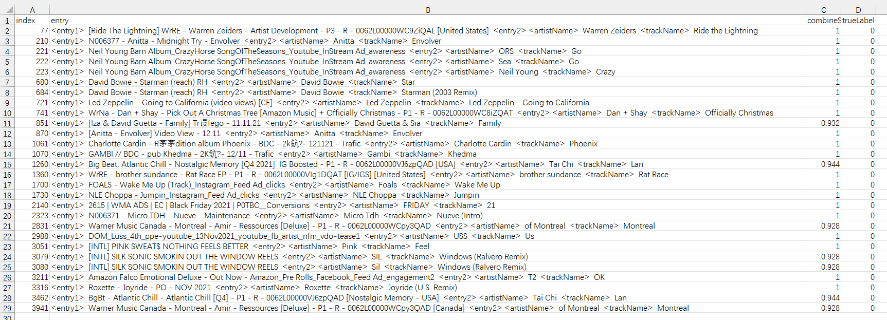
   1. Not sure:
      1. #77 - track name is at front
      2. #210 - separated artist and trackname
      3. #721 is special case -- trackname contains the artist name
   2. Fuzzy wuzzy limitation:
      1. 221, 222, 223, 680,1260, 2140，2831,2988,3051, 3079, 3080, 3211, 3462, 3941
   3. Incorrect label:
      1. 684, 721,741,851,870, 1061,1070,1360, 1700, 1730, 2323，3316,
      2. Mostly due to a separation between artist and track name in the campaign name